Health Data Analysis Using R
Introduction
This activity involved using the Health Data dataset in R to apply descriptive statistics, data visualisation and hypothesis testing. The tasks involved calculating the mean, median and mode of systolic blood pressure (SBP), diastolic blood pressure (DBP) and income; producing a five-number summary and boxplot for income; and investigating whether systolic blood pressure differed according to the presence or absence of peptic ulcer.
1. Importing and Exploring the Dataset
The dataset was provided as an SPSS .sav file. I imported it into R using the foreign package and checked the variable names before beginning the analysis.
This confirmed that the dataset contained the required variables, including sbp, dbp, income and pepticulcer.

2. Mean, Median and Mode
I calculated the mean and median for SBP, DBP and income using R.
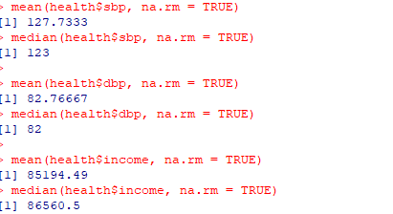
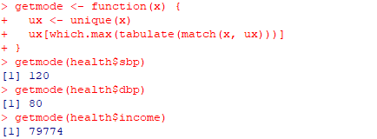
A function was also created to calculate the mode:

Variable | Mean | Median | Mode
SBP | 127.73 | 123 | 120
DBP | 82.77 | 82 | 80
Income | 85,194.49 | 86,560.5 | 79,774

The results show that the mean, median and mode varied slightly across the three variables. For DBP, the three measures were relatively similar, whereas SBP showed a somewhat higher mean than median and mode.

3. Five-Number Summary and Boxplot of Income
I used the following commands to calculate the five-number summary:
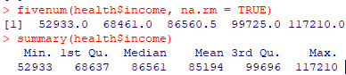

Measure | Value
Minimum | 52,933
Q1 | 68,461
Median | 86,560.5
Q3 | 99,725
Maximum | 117,210


I then created a boxplot:

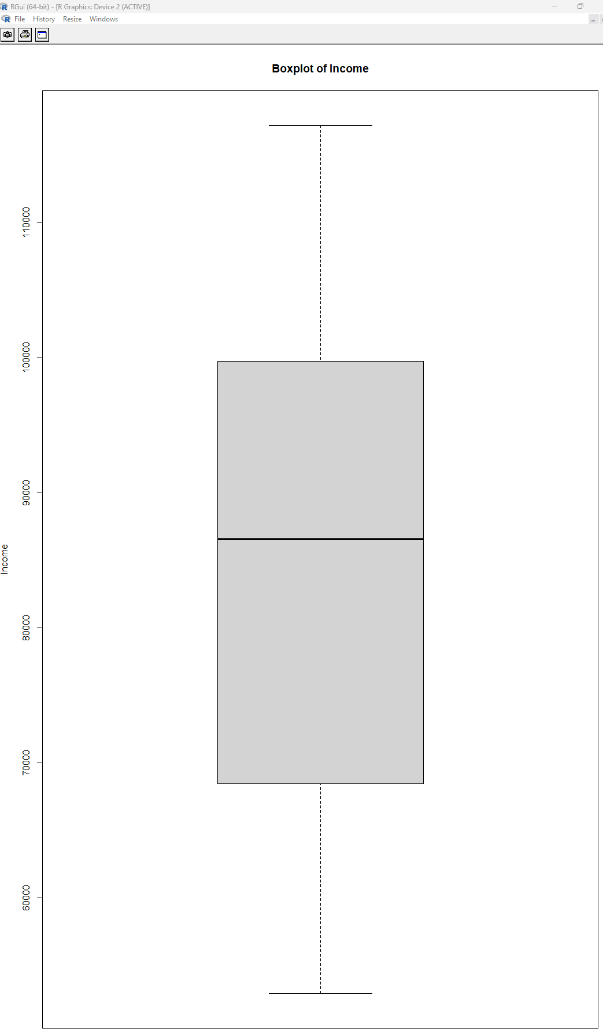

The middle 50% of income values were between 68,461 and 99,725, with a median of 86,560.5. The boxplot also showed no obvious outliers.
4. Hypothesis Test: SBP and Peptic Ulcer
The final task investigated whether systolic blood pressure differed between participants with and without peptic ulcer.
As SBP is a continuous variable and peptic ulcer status consists of two independent groups, a two-sample t-test was used to compare the mean SBP between the groups (Bader and Leuzinger, 2025).

The hypotheses were:
H₀: There is no difference in mean systolic blood pressure between participants with and without peptic ulcer.
H₁: There is a difference in mean systolic blood pressure between participants with and without peptic ulcer.
I first examined the groups:
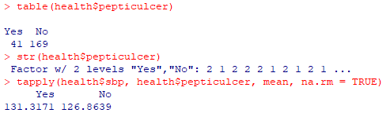

There were 41 participants with peptic ulcer and 169 without. Mean SBP was 131.32 mmHg for participants with peptic ulcer and 126.86 mmHg for those without.
I then performed a Welch two-sample t-test:
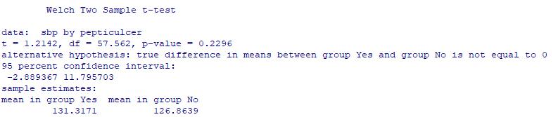

The test produced:
t = 1.214, p = 0.2296, 95% CI = −2.89 to 11.80
Although mean SBP was approximately 4.45 mmHg higher among participants with peptic ulcer, the difference was not statistically significant (p = 0.2296). The 95% confidence interval also included zero (−2.89 to 11.80), indicating uncertainty about the direction and magnitude of the difference. Therefore, the null hypothesis was not rejected, and there was insufficient evidence to conclude that mean SBP differed between participants with and without peptic ulcer. This demonstrates why p-values should be considered alongside confidence intervals when interpreting statistical findings (Patrick, Bossers and Schwarte, 2018).

Reflection
This activity developed my practical understanding of using R for both descriptive and inferential statistical analysis. I was able to calculate measures of central tendency, use a five-number summary and boxplot to examine a distribution, and apply a hypothesis test to compare two groups. An important learning point was that an observed difference between groups does not necessarily indicate a statistically significant difference. Although participants with peptic ulcer had a higher mean SBP, the hypothesis test showed insufficient evidence to conclude that this difference was statistically significant. This reinforced the importance of considering p-values and confidence intervals when interpreting statistical findings rather than relying only on differences in descriptive statistics.
References
- Bader, M. and Leuzinger, S. (2025) R-ticulate: A Beginner’s Guide to Data Analysis for Natural Scientists. 1st edn. Hoboken: Wiley.
- Patrick, S., Bossers, S.M. and Schwarte, L.A. (2018) ‘Statistical significance versus clinical importance of observed effect sizes: what do P values and confidence intervals really represent?’, Anesthesia & Analgesia, 126(3), pp. 1068–1072.

